Chino Valley Unified School District
Band Registration

Welcome back to a new school year! I am excited that your child has expressed an interest in the CVUSD band program!

CVUSD offers students in grades 5 and 6 the opportunity to learn one of the following instruments:

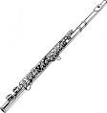FLUTE 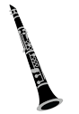 CLARINET 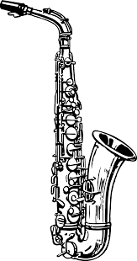SAXOPHONE
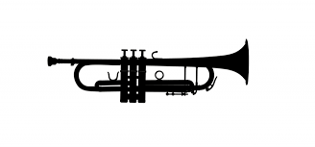TRUMPET 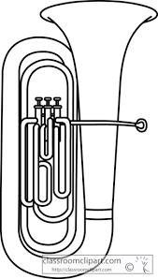 BARITONE 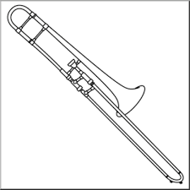TROMBONE
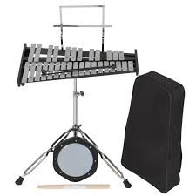
PERCUSSION (drum kit needed and includes bell set/mallets and drum pad/drum sticks)

The district does not provide band instruments for student use, although the district has a limited amount of instruments to loan 4767(at no cost) through the district’s loaner program. Forms for this program are in the office and need to be returned as soon as possible. This program is based on financial need. Otherwise, parents are responsible for purchasing or renting an instrument if one is not available to borrow from friends or family.
(We encourage students to rent an instrument their first year. If you do purchase an instrument, do not purchase an instrument from a warehouse, toy, or discount department store. Although the low price is attractive, they are very low quality and will create a frustrating playing experience for your child!)

Once you have acquired an instrument, you will need to purchase the following supplies:

Method book: Tradition of Excellence, book 1 for your instrument, luggage tag and a pencil

*Clarinet and Sax players only: 5 reeds, size 1 1/2 (as they break, they will need replacements during the school year), cleaner, cork grease
*Trumpet players: valve oil, old wash cloth
*Trombone players: slide grease, old wash cloth
*Flute players: cleaning rod and cloth
*Percussion players: drum kit (includes bells, drum pad and sticks/mallets)

Supplies can be purchased through amazon or local music stores (ex. Sam Ash, Guitar Center, Gards, KYR, Music and Arts etc.)

Please note that students are expected to practice at home. Students who do not practice are rarely successful in a school band program. My standard is 15 minutes per day, 5 days per week. If a child cannot practice every day, he/she should still try to put in 75-90 minutes per week in fewer days’ time, although this is less desirable for retaining skills. Discussion will take place in class about the best way to practice at home.

*Interested students should fill out a Band Registration Form and turn it into your classroom teacher or the office.

The band schedule begins the week of August 29th
Students do not need an instrument for the first week of band.

Advanced Band (returning band members) meet:
Tuesday,10:15-11 am, 10:50-11:35

Beginning Band members meet in groups by instrument

Beginning Band A- clarinets/saxes/flutes
Monday 12:35-1:10, Thursday 1:15-1:50
Beginning Band B- trumpets/french horns/baritones/trombones
Monday 1:15-1:50, Thursday 12:35-1:10
I know this is a lot of information, and I hope it’s all clear! For answers to your questions, the fastest way to reach me is via email: Pam_Bell@chino.k12.ca.us.

Pamela Bell
Levi Dickey Elementary Music Director
Liberty Elementary Music Director
Woodcrest JHS Band and Choir Director

